CEO/CFO Financial Statements and IRS Form 990 Certification
I hereby certify that:
- I have reviewed the audited financial statements and IRS Form 990 of United Way of Central Ohio for the year ended March 31, 2021;

- Based on my knowledge, these documents do not contain any untrue statement of a material fact or omit any material facts necessary which would make the data or information misleading;

- Based on my knowledge, the financial statements and other financial information included in these reports, fairly present, in all material respects, the financial condition, results of operations and cash flows of United Way of Central Ohio as of, and for the period ended March 31, 2021;

- I understand that I am responsible for the organization's internal controls and disclosure procedures and I have communicated any known deficiencies and material changes in internal controls to the auditors as a part of the audit process.

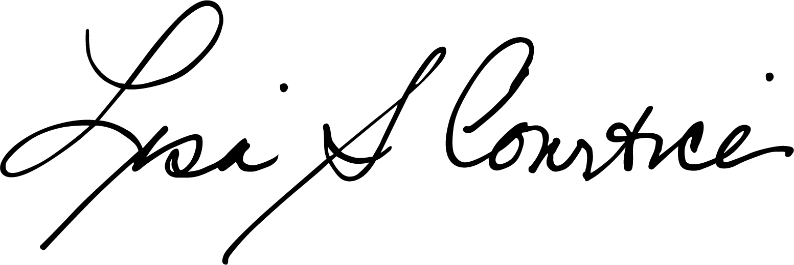
_____________________________ 8/17/2021
Lisa S. Courtice, Ph.D.
President & CEO Date

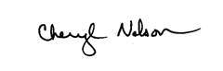 8/17/2021
Cheryl Nelson
Sr. Vice President, Finance & CFO Date

